**CP3405**

**Design Thinking and Project Management**

**Assignment Two**

**Proposal for App-igration**

**Report compiled by:**

**Anumolu Sandeep Prasad 13156974**

**Constant Hughes - Treherne 13340384**

**Udaya Bhaskar Reddy Malkannagari 13368171**

**Lum Kwan Wei Brandon 13379339**

**Application link:**

<https://drive.google.com/open?id=1gKKOkoRLty5bA7pKAM4rYzhu2FNDIVGX>

**Github link:**

[**https://github.com/LKWBrando/Appigration**](https://github.com/LKWBrando/Appigration)

**Audio_video link:**

(Google-Drive folder)

<https://drive.google.com/open?id=1b5AZmfQzWUIk5KsvuEFs6Hscz3YgqtEs>

**1. Introduction** **4**

1.1 Scrum Set-up: 4

1.2 Sprint Forecast 4

**2. Sprint Details** **5**

2.1 Scrum Roles 6

2.2 Personas of users 7

**3. Sprint Planning** **10**

3.1 Practical 4 10

3.1.1 Scrum board at the beginning of Sprint 1 10

3.1.2 Stories created for Sprint 1 11

3.2 Practical 5 13

3.2.1 Audio recording of your Daily Standup (Evidence 3) 13

3.2.2 Identified Blockers 13

3.2.3 Burnout chart of Sprint 1 13

3.2.4 Scrum board at the beginning of Sprint 2 14

3.2.5 Stories created for Sprint 2 15

3.3 Practical 6: 17

3.3.1 Video recording of your Scrum Demo (Evidence 7) 17

3.3.2 Identified Blockers 17

3.3.3 Burnout chart of Sprint 2 (Evidence 8) 19

Burndown of Sprint 2 19

3.3.4 Scrum board at the beginning of Sprint 3 20

3.3.5 Stories created for Sprint 3 21

3.4 Practical 7: 24

3.4.1 Summary of Scrum Retrospective 24

3.4.1.1 What went well? 24

3.4.1.2 What didn’t go well? 24

3.4.1.3 What should we do about it? 24

3.4.3 Burnout chart of Sprint 3 24

Burndown of Sprint 3 25

3.5 Practical 8: 25

3.5.1 Scrum board at the beginning of Sprint 4 25

3.5.2 Stories created for Sprint 4 26

3.5.4 Burndown chart of Sprint 4 28

Burndown of Sprint 4 28

3.6 Lecture 8 29

3.6.1 Mistakes made in the scrum rituals (Evidence 18) 29

3.7 Lecture 9 32

3.7.1 Scrum values of the team (Evidence 19) 32

3.8 Final Lecture 33

3.8.1 Present the velocity chart of your team (Evidence 20) 33

# 

# 

# 1. Introduction

Appi-Gration is a Android application which boasts a large suite of helpful functions to assist new immigrants in Singapore. The application itself caters for those who are new and alien to the country of new residence. With an easy and intuitive UI the user is able to search for property either for purchase or renting in the new location. This simplifies their arrival and worries of finding accommodation.

A user can easily browse the application without having the need to create an account. However, a user can also create an account which offers more personalization options and predictions based on the users profile. Appi-Gration has both a rent and buy page which filters results of their preference. A user can also list a property for purchase or hire. Included in the suite of features is the ability to see nearby shops, public transport services and other points of interest in our search function for the user. They can use their current location to find points of interests.

## 1.1 Scrum Set-up:

Scrum Master: Anumolu Sandeep Prasad

Product Owner: Udaya Bhaskar Reddy Malkannagari

Development Team: Constant Hughes - Treherne, Lum Kwan Wei Brandon

## 1.2 Sprint Forecast

The initial set-up of our Sprint forecast included 4 Sprints which needed to be executed in order to finish all the work, and finish the application with its feature list. 4 sprints are used to develop 4 features and the corresponding documentation, and relevant charts. Each Sprint is based off a weeks work, and an interval was set between Sprint 2 and 3, as we used this time to evaluate progress and contributions.

# 

# 

# 2. Sprint Details

**Sprint 1**

**Duration:** 18 December - 24 December

**Purpose:**

This Sprint focused on the development of general UI of the application and the navigation.

**Sprint 2**

**Duration**: 1 January - 7 January

**Purpose:**

Sprint 2 saw the development of the user registration function, and integrating it with the user database.

**Sprint 3**

**Duration:** 8 January - 14 January

**Purpose:**

Sprint 3 focussed on the development of the login page which allowed authorized access to the user.

**Sprint 4**

**Duration:** 15 January - 21 January

**Purpose:**

Sprint 4 saw the search functionality of the application. The user can now search the places of interest based on personalized choices using google maps.

|  |  |
| --- | --- |
| **Sprint** | **Duration** |
| Sprint 1 | December 18 - December 24 |
| Sprint 2 | January 1 - January 7 |
| Sprint 3 | January 8 - January 14 |
| Sprint 4 | January 15 - January 21 |

## 

## 

## 2.1 Scrum Roles

**Scrum Master: Sandeep**

The Scrum master, Sandeep, was in-charge of finding developers for the development team. He allocated these roles to Constant and Brandon.

**Responsibilities:**

* Planning the scrum rituals which include our daily standup meetings, scrum demo and the scrum retrospective
* Identifying any blockers found during the development process
* Working with the product owner to help clarify user stories and maintain a detailed back log
* Ensure the timeline for each sprint is met

**Product Owner: Uday**

The Product Owner, Uday, was the voice of the user. He was a natural choice for this role as the project is based upon his level 2 module designs. He has already worked with the designers of the previous project and made sure the design assets were ready for the team.

**Responsibilities:**

* Overlook the state of the product and the timeline of each sprint
* Identifying features based on priority for each Sprint
* Planning the sequence of the user stories based on the velocity and development of the project
* Communicating with the developers to confirm if the features were in concurrence with the user stories
* Incharge of the visual studio

**Development Team: Constant, Brandon**

The project had a two-man development team, Brandon and Constant. The scrum master had identified their capabilities in coding and allocated them roles in developing the product to the product owner's specifications.

# 

## 2.2 Personas of users

**Mr Mike Litoris**

Name: Mike Litoris Sex: Male Age: 53

Nationality: Swedish

Occupation: Financial Analyst

Background:

Working in finance for a large banking corporation the job requires Mike to travel a lot, and on occasions immigrate to new countries. Mike has spent a lot of time outside of his birth country.

On numerous occasions Mike has had to stay in countries for 3 to 6 months as part of a training management team. As a single male this has not had a tremendous negative impact on his life in regards to family matters.

Requirement:

Constantly immigrating to new countries and frequently visiting countries for prolonged periods Mike requires an application to assist in short term accommodation close by to his workplace as purchasing a vehicle would be financially irresponsible.

As for being new to a country, the application would benefit a lot by having information regarding local tourist sites for visiting, and local spots for shopping, buying groceries and other points of interest.

**Mr Ben Dover**

Name: Ben Dover Sex: Male Age: 37

Nationality: British

Occupation: Regional Manager for Continental

Background:

Ben is established in his line of work, and has been selected to migrate to Cape Town to take over another regional managers position. This opportunity will require the relocation of himself, partner and 3 children. The move will put a lot of pressure on Ben, specifically because of schooling for the children, and to ensure work for his wife when they arrive. Along with the transition to a new country the family need to find a house before moving, and help migrate the family dog, which the children cannot live without.

Requirements:

A quick search for an appropriate neighborhood with easy access to a primary and high school is top priority, the neighborhood should also be in close proximity to the office for Ben.

Being the first time moving out of England the family are unfamiliar with culture, food and entertainment. If these elements can be fulfilled the transition will be effortless and automated. Location and convenience is important, if an application can cater for appropriate search results with a set list of preferences it would suffice, along with extra information about schools, local parks, and shopping centers.

**Deriving Features from User Stories**

Searching by Location

There is a need for a feature that allows the user to search for available properties based on his location. As per our created personas, creating a feature that would allow a user to pinpoint possible locations within a specific area would contribute greatly towards helping them find a suitable location to settle. Such examples include listing available facilities such as gyms, swimming pools, and schools around the listed properties.

Continue browsing

Introducing a user to the application can be a challenging component. While we do want potential users to register with our service, some users might be put off by the idea of having to divulge potentially personal information in order to view our application and how it works. As such, the user must be allowed to have access to view all available listings. Certain features will still be locked behind a registration component, but by allowing users to bypass a potentially time-consuming task will help greatly in promoting the user friendliness of the application.

User database

Continuing on from the above point, there is a need for a database to store all the personal information that the users have used to register with our service. These information include their personal phone numbers, emails, username and passwords, as well as their own listings and preferences. We can preferably set up a simple database at the start, so as to show the proof of concept, before investing resources in acquiring a secure and stable database server.

Good landing page

In general, the user experience is greatly improved when the application is aesthetically pleasing as a whole. A good home screen that leads to other functionalities within the application is required, as well as to ensure that not too many clicks are required to reach a feature that the user desires. Good implementation of a landing page will help us improve and simplify our navigation, and ensure the users are not overwhelmed when visiting the application.

Personalized account

Another good point to include is to personalise the user’s account. We can do this by displaying, or editing, messages to include the user’s name. We can also pull the relevant information for the user’s actions. For example, if the user has chosen a property to rent and has confirmed his choice, we can push forward and relay his contact information directly to the associated listing, helping the users bridge with each other without having to involve them in the back-end transactions.

**User Stories:**

The product owner was incharge of communicating the user stories with the development team. He acted as the guiding link between the team and the user. A total of five user stories were developed in the beginning. But owing to the time constraints, four user stories were selected based on the functionality of the features to be implemented.

We now look at the user story and its implementation in each sprint in the table below.

|  |  |  |
| --- | --- | --- |
| **User Story** | **Proposed Feature** | **Implementation in Sprint** |
| Improved navigation and browse without a user account | General design of the UI along with a browsing functionality | Sprint 1 |
| Authenticate user registration | Register functionality | Sprint 2 |
| Authenticate login | Login Functionality | Sprint 3 |
| Search for a house on map | Map functionality | Sprint 4 |

All these user stories were split into smaller tasks which will be explained in detail in the subsequent sections along with the evidences and the actual working functionality of the app.

# 

# 

# 3. Sprint Planning

## 3.1 Practical 4

### 3.1.1 Scrum board at the beginning of Sprint 1

Figure 3.1a, below, is a screenshot of the scrum board at the beginning of Sprint 1 (Evidence 1)

|  |
| --- |
| SPRINT 1 |
| [Figure 1] |

Figure 3.1a - Evidence 1, Scrum Board

### 

### 

### 3.1.2 Stories created for Sprint 1

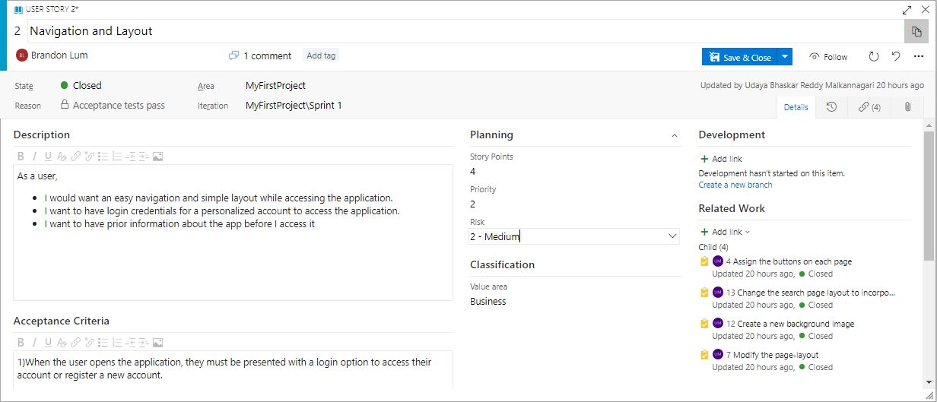

*Figure 3.1b - Evidence 2, Stories*

(Story points allocated - 4, Estimated priority - 2)

**Story #1**

Title: Application structure and description

As a: New user

I want to: Understand what the app offers, and the functionalities within it

So that: A first time user understands what the app is about and what it offers before exploring any further.

**Story #2**

Title: Navigation layout and browsing

As a: New user

I want to: navigate through the different pages of the application with ease

So that: The user can get from one area of the application to another where they want to interact with a feature.

**Acceptance Criteria**

* Easily visible and functioning buttons
* Layout accessible on multiple devices
* ‘Two-click’ functionality
* Start page contains brief textual info about the app
* ‘Continue browsing’ feature is incorporated

|  |
| --- |
| SPRINT 1 - END |
|  |

*Figure 3.1c - Scrum Board at the end of the Sprint 1*

Functionality achieved:

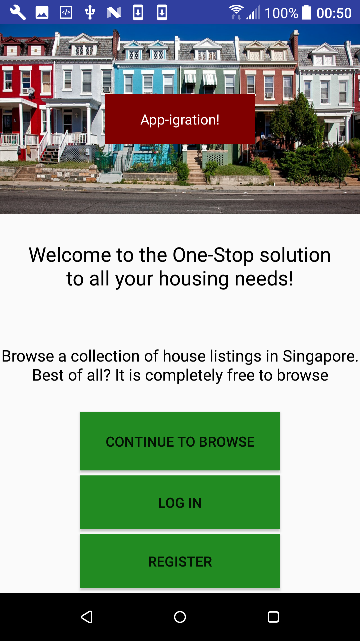 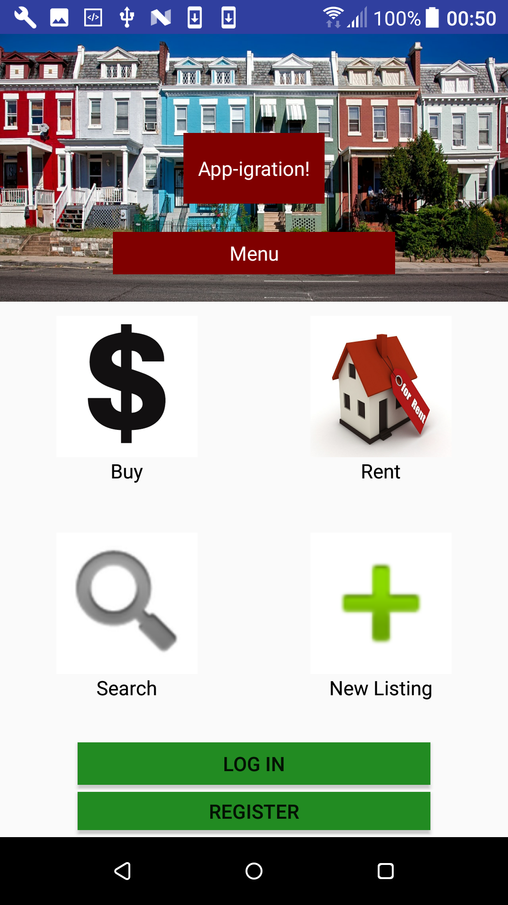

The continue browsing feature on the landing page which allows the user to access the application without creating a user account. General UI and navigation is improved with a ‘two-click’ functionality.

## 3.2 Practical 5

### 3.2.1 Audio recording of your Daily Standup (Evidence 3)

<https://drive.google.com/open?id=1OFnPMJ8xczjVFRvqXKA5N6Lg06xqskif>

### 3.2.2 Identified Blockers

Throughout the course of our first sprint, our team faced an issue with the concept and allocation of user stories to the backlog. Once we held our weekly meeting and further deliberated on the topic, we understood the proper methodology and repaired our scrum board with the appropriate posts. We also had further discussions with the product owner to ensure accurate representation of their acceptance criteria for these user stories.

### 3.2.3 Burnout chart of Sprint 1

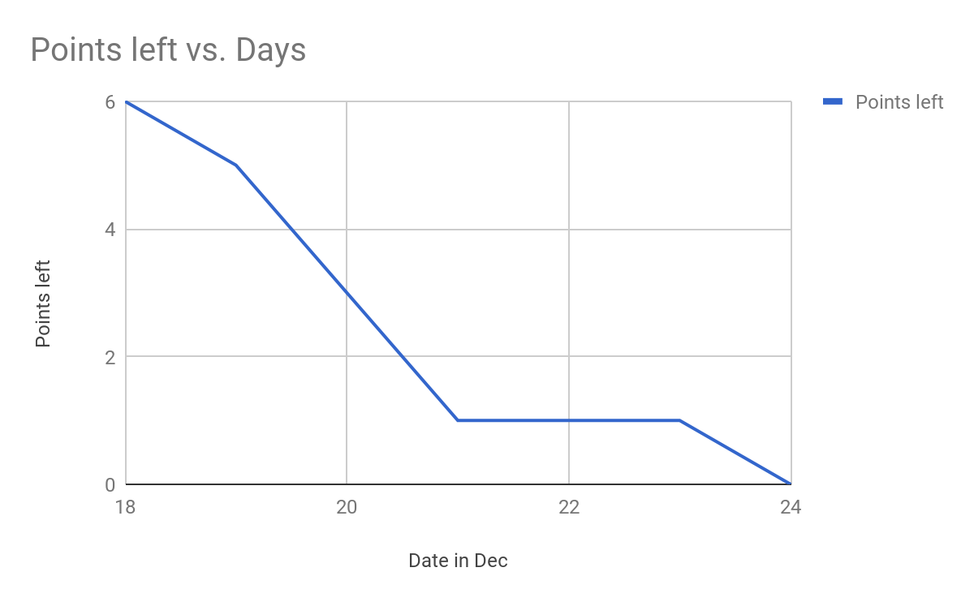

*Fig. 3.2a - Evidence 4, Burndown chart of Sprint 1*

Burndown for Sprint 1

Sprint 1 was focused around the development of the UI and general navigation. This was our main focus of functionality that needed to work after Sprint 1 had concluded. From evidence 4 it is presented that a slow start to progress was present however closer to the end of the week progress was more significant, and all work was completed by the set deadline.

### 3.2.4 Scrum board at the beginning of Sprint 2

Figure 3.2b, below, is a screenshot of the scrum board at the beginning of Sprint 2 (Evidence 5)

|  |
| --- |
| SPRINT 2 - START |
|  |

*Fig. 3.2b - Evidence 5, Scrum Board*

### 

### 

### 3.2.5 Stories created for Sprint 2

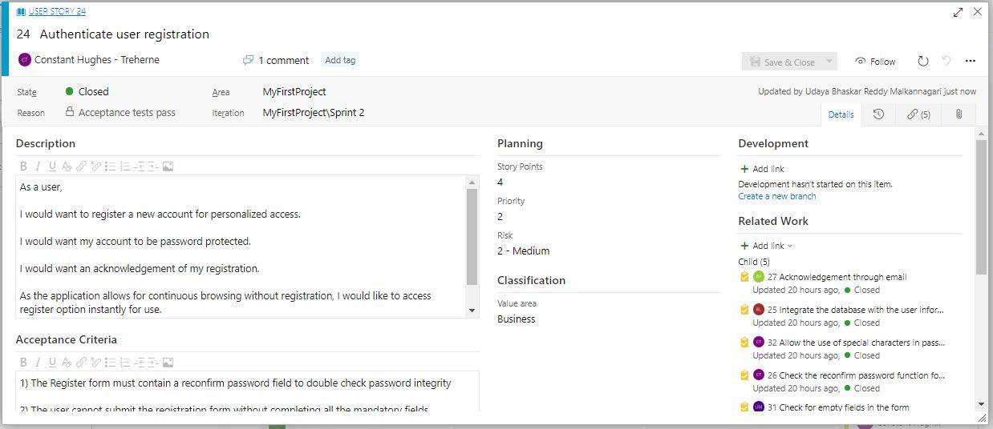

*Fig. 3.2c - Evidence 6, User Stories*

*(Total Story points allocated 4, estimated priority is 2)*

**Story #1**

Title: Authenticate user registration

As a: New user

I want to: Have authorized access to use the application.

So that: The user can create a personalized account and filter options to his needs and requirements.

**Story #2**

Title: Password protection

As a: Registering user

I want to:Have a secured access to the application with strong password protection.

So that:The user can be assured that his identity and information is protected and no one else has access to his personalized data within the application.

**Story #3**

Title: Integrate registration information with the user database.

As a: Registered user

I want to: See updated listings upon a new login to my account

So that: The user is not required to scan through all the previous houses he has already checked. This will avoid redundancy and increase the user-friendliness and usability of the application.

**Acceptance Criteria**

* Account is password protected
* Confirm password prompts an error on wrong input
* Registration success is displayed on the screen
* Registration information is stored in the user database

|  |
| --- |
| SPRINT 2 - END |
|  |

*Figure 3.2d - Scrum Board at the end of the Sprint 2*

**Functionality achieved for Sprint 2:**

The registration feature was successfully implemented into the prototype. The database is updated with the user’s information as per the registration input fields, and the correct display messages are shown as per user’s action.

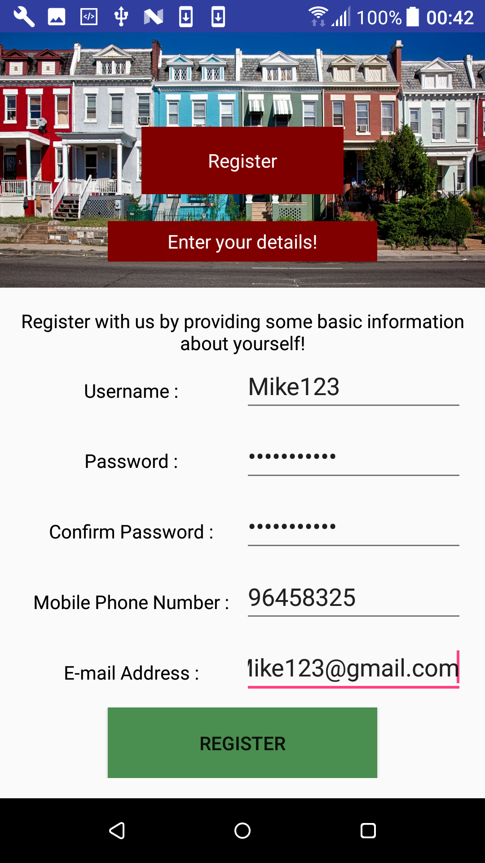 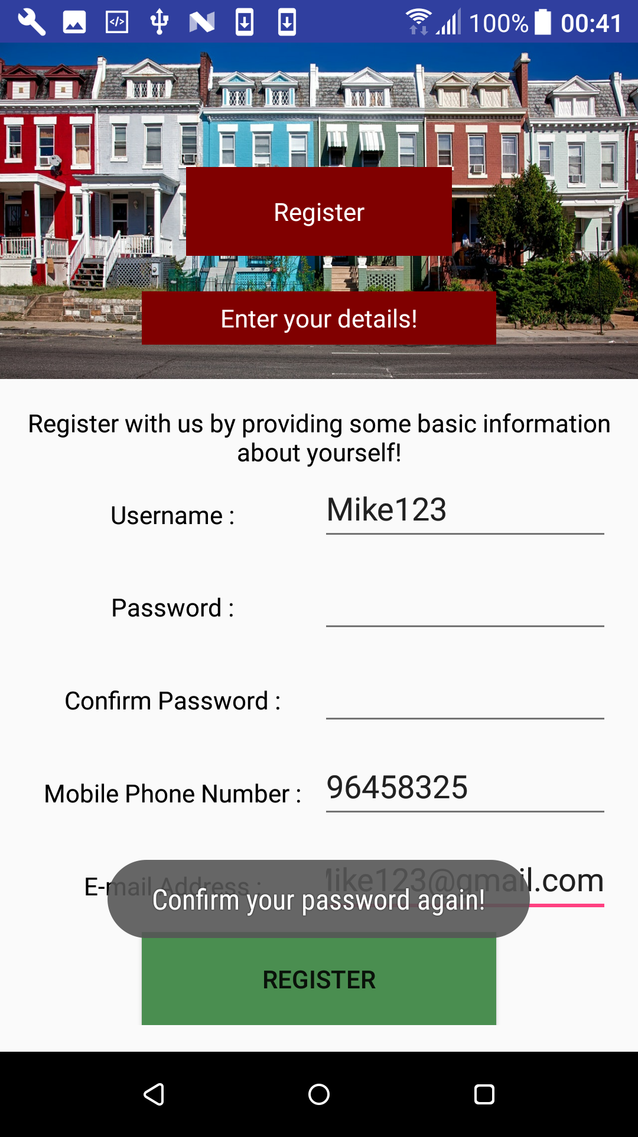 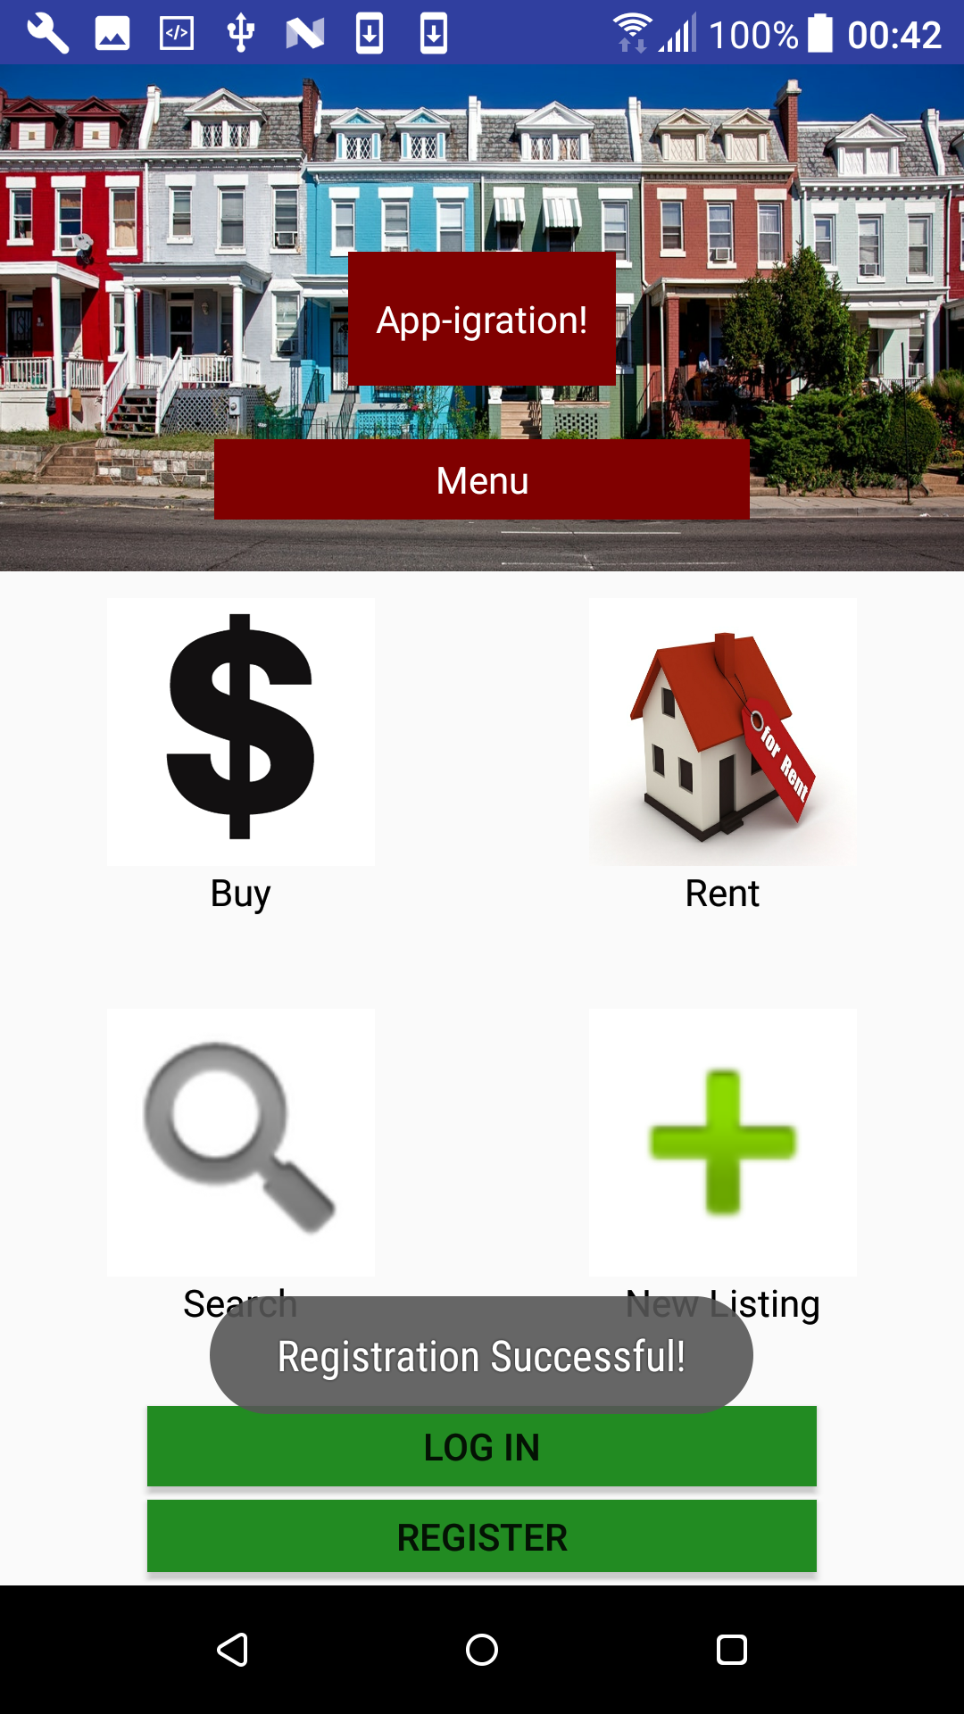

*Figures 3.2e, 3.2f, 3.2g respectively (Left to right)*

## 3.3 Practical 6:

### 3.3.1 Video recording of your Scrum Demo (Evidence 7)

<https://drive.google.com/open?id=1tWePJaaN3EWwG6cNszGfgwOHvUwzuTel>

Audio recording:

<https://drive.google.com/open?id=1EQOzSWpxIwtch_6uS89I5GyEXHBJuPQd>

### 3.3.2 Identified Blockers

In the course of our second sprint, our development team faced an issue of alignment of the buttons. The scaling of the page needed to be adjusted before the fields were aligned correctly. The product owner has also raised this issue in one of the scrum meetings. We also had further discussions with the product owner to ensure accurate representation of their acceptance criteria for these user stories.

### 

### 3.3.3 Burnout chart of Sprint 2 (Evidence 8)

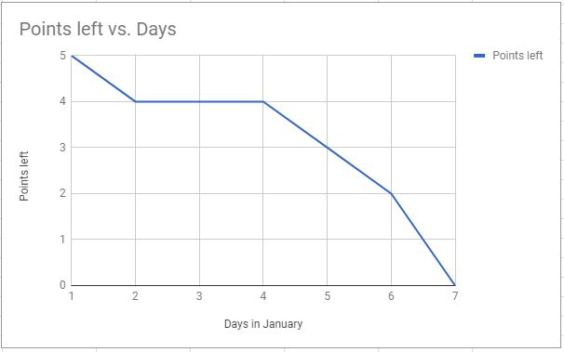

*Fig. 3.3a - Evidence 8, Burndown chart of Sprint 2*

### Burndown of Sprint 2

Evidence 8 portrays a slow start, and some plateau of work done for the first 4 days.

Once all resources were allocated the development team were able to quickly resolve issues and complete requested functionality in the last 3 days.

### 

### 

### 3.3.4 Scrum board at the beginning of Sprint 3

Figure 3.3b, below, is a screenshot of the scrum board at the beginning of Sprint 3

|  |
| --- |
| SPRINT 3 - START |
|  |

*Fig 3.3b - Evidence 9, Scrum Board*

### 

### 

### 3.3.5 Stories created for Sprint 3

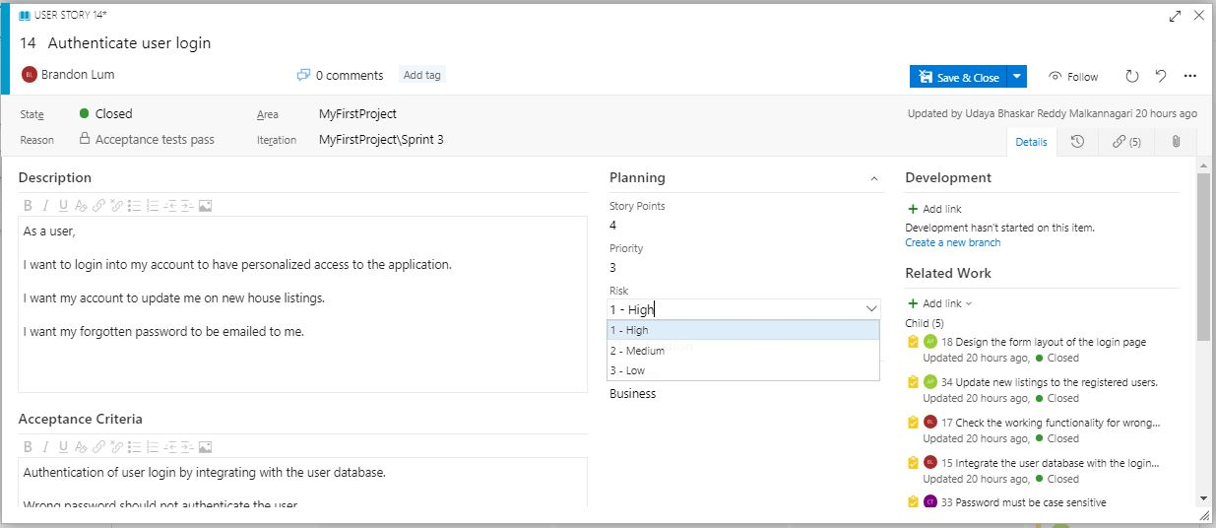

*Fig. 3.3c - Evidence 10, User Stories*

*(Total Story Points is 4, priority is 3 and risk is set to High)*

**Story #1**

Title: Authenticate user login

As a: Registered user

I want to: Login in to my account

So that: Access personalized information and new listings without having to scan through the whole selections again

**Story #2**

Title: Acknowledge login with the username

As a: Registered user

I want to: a confirmation for my account login

So that: the user can be assured of the security and privacy of his account.

**Story #3**

Title: Acknowledgement for account logout

As a: Registered user

I want to: A confirmation for exiting the account

So that: The user can be assured that he has logged out of his account and further access to his personalized account is prohibited.

**Acceptance Criteria**

* Wrong input should not authenticate
* Password can accept special characters
* Password is case-sensitive
* Login is authenticated by welcoming the user with his username
* Successful log out is prompted on the screen upon exiting the account

|  |
| --- |
| SPRINT 3 - END |
|  |

*Figure 3.3d - Scrum Board at the end of the Sprint 3*

**Functionality achieved:**

The login feature has been implemented successfully. The application is able to pull the information from the database and compare it with the user’s input. Successful matches allow the user to proceed, and unsuccessful messages produce an error message.

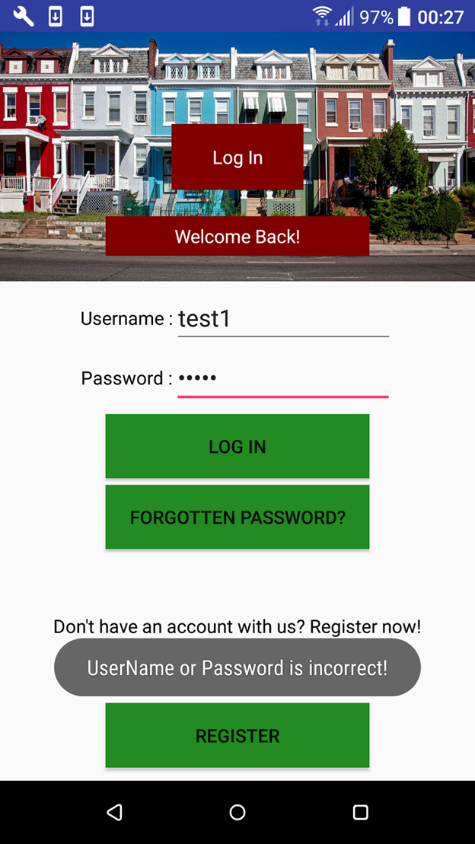 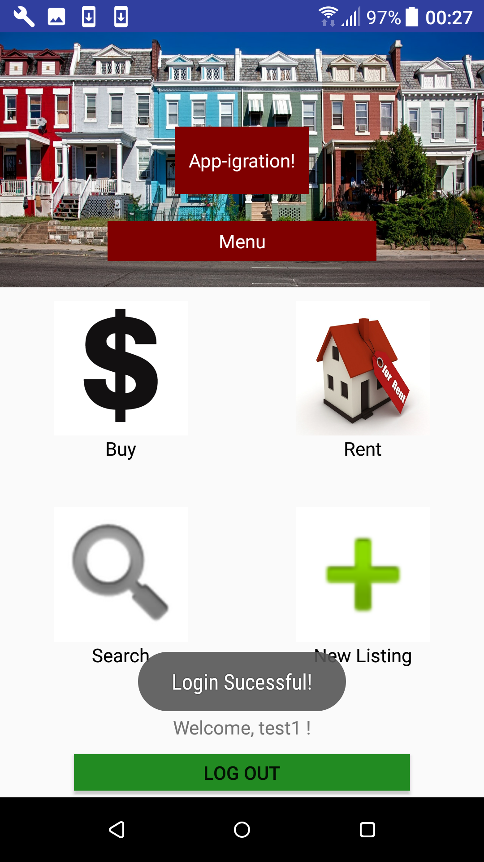 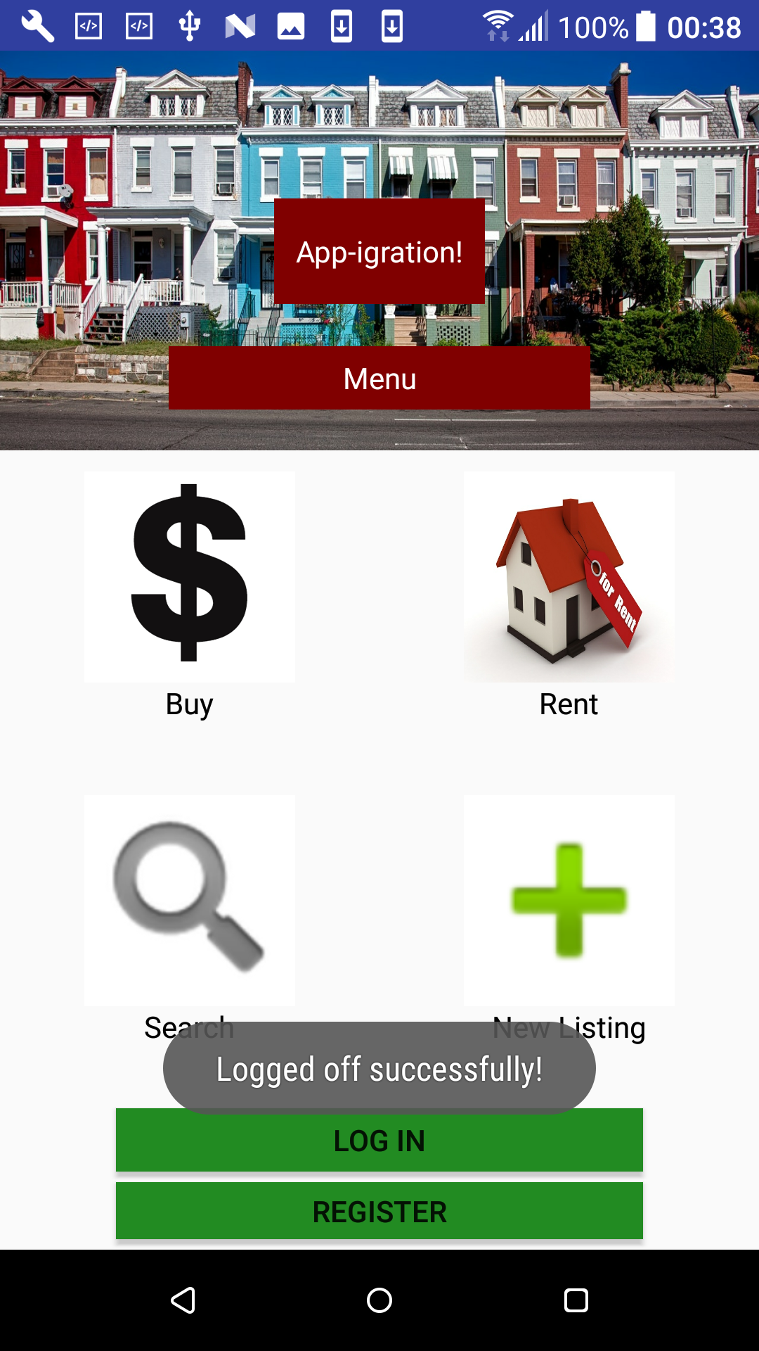

*Figures 3.3e, 3.3f, 3.3g respectively (Left to right)*

The images above display the functionality achieved for successful login and logout.

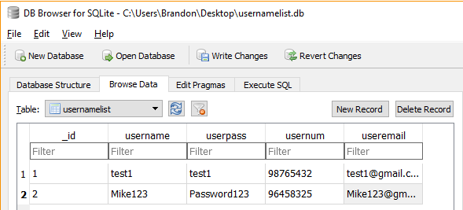

*Fig. 3.3h*

Figure 3.3h (above) displays the code showing the user database integration through SQL.

## 3.4 Practical 7:

### 3.4.1 Summary of Scrum Retrospective

*3.4.1 A summary of Scrum Retrospective that includes a list what each team member mentioned for each of these questions (Evidence 11)*

#### 3.4.1.1 What went well?

The login feature was implemented successfully and the application was able to access the user database.

#### 3.4.1.2 What didn’t go well?

The product owner raised the issue of the alignment of buttons.

#### 3.4.1.3 What should we do about it?

Check for any inconsistencies in the alignment and resolve them.

3.4.2 Audio recording of our meeting:

<https://drive.google.com/open?id=1KYPNbnXj47t0T4pi34s4s9p0oKp78Y9U>

### 3.4.3 Burnout chart of Sprint 3

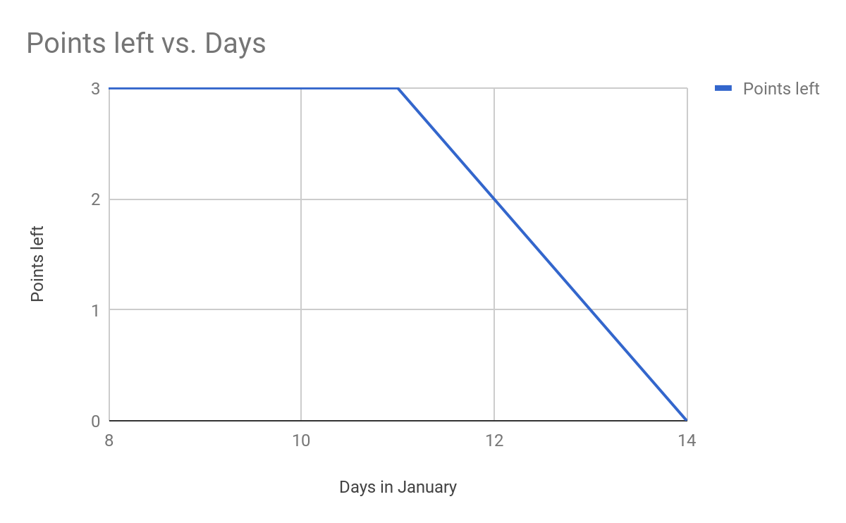

*Fig. 3.4a - Evidence 13, Burndown chart of Sprint 3*

### Burndown of Sprint 3

Evidence 13 shows a long stagnant amount of time where no progress was established, here effort ran low, however all requested points were executed in a short period of time, the stagnant time was observed as taking caution when trying to fill in functionality in a short amount of time.

## 3.5 Practical 8:

### 3.5.1 Scrum board at the beginning of Sprint 4

Figure 3.5a, below, is a screenshot of the scrum board at the beginning of Sprint 4

|  |
| --- |
| SPRINT 4 - START |
| [Figure 4] |

*Fig 3.5a - Evidence 13, Scrum Board*

### 

### 

### 

### 3.5.2 Stories created for Sprint 4

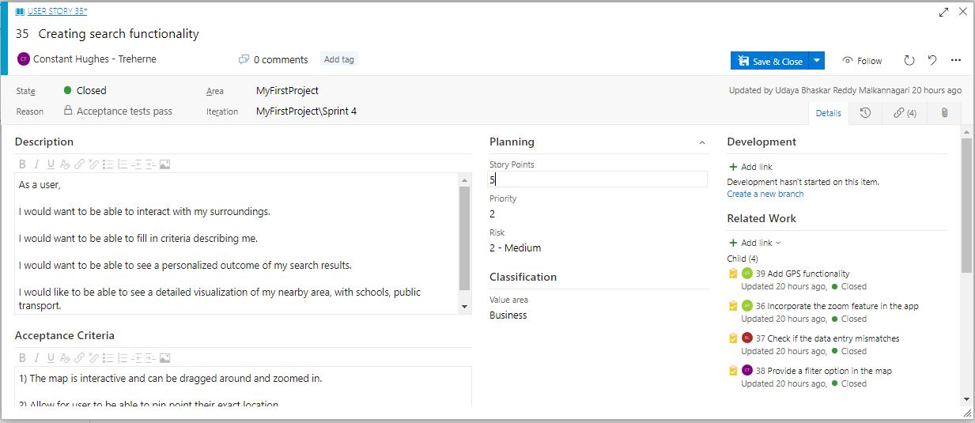

*Fig. 3.5b - Evidence 14, User Stories*

*(Total Story points is 5 and the priority is 3 with medium risk)*

**Story #1**

Title: Map for nearby facilities locations

As a: Registered user

I want to: Be able to navigate with a map once the property has been selected and see all the schools and hospitals in the nearby area.

So that: The app has more features to offer within the application and the user does not have to go to other apps to browse the basic feature of being able to see nearby instances on the map..

**Story #2**

Title: Interaction with the map

As a: Registered user

I want to: Be able to zoom into the map, scroll around, and be able to change my preferences within the application to show routes, and other properties for comparison purposes.

So that: The user is able to explore the map, and compare this current location with another one before going ahead and renting or purchasing the property.

**Acceptance Criteria**

* User is able to scroll around map
* Use location services such as GPS
* Search for their preferences
* Tick boxes to narrow down search

|  |
| --- |
| SPRINT 4 - END |
|  |

*Figure 3.5c - Scrum Board at the end of the Sprint 4*

**Functionality achieved:**

 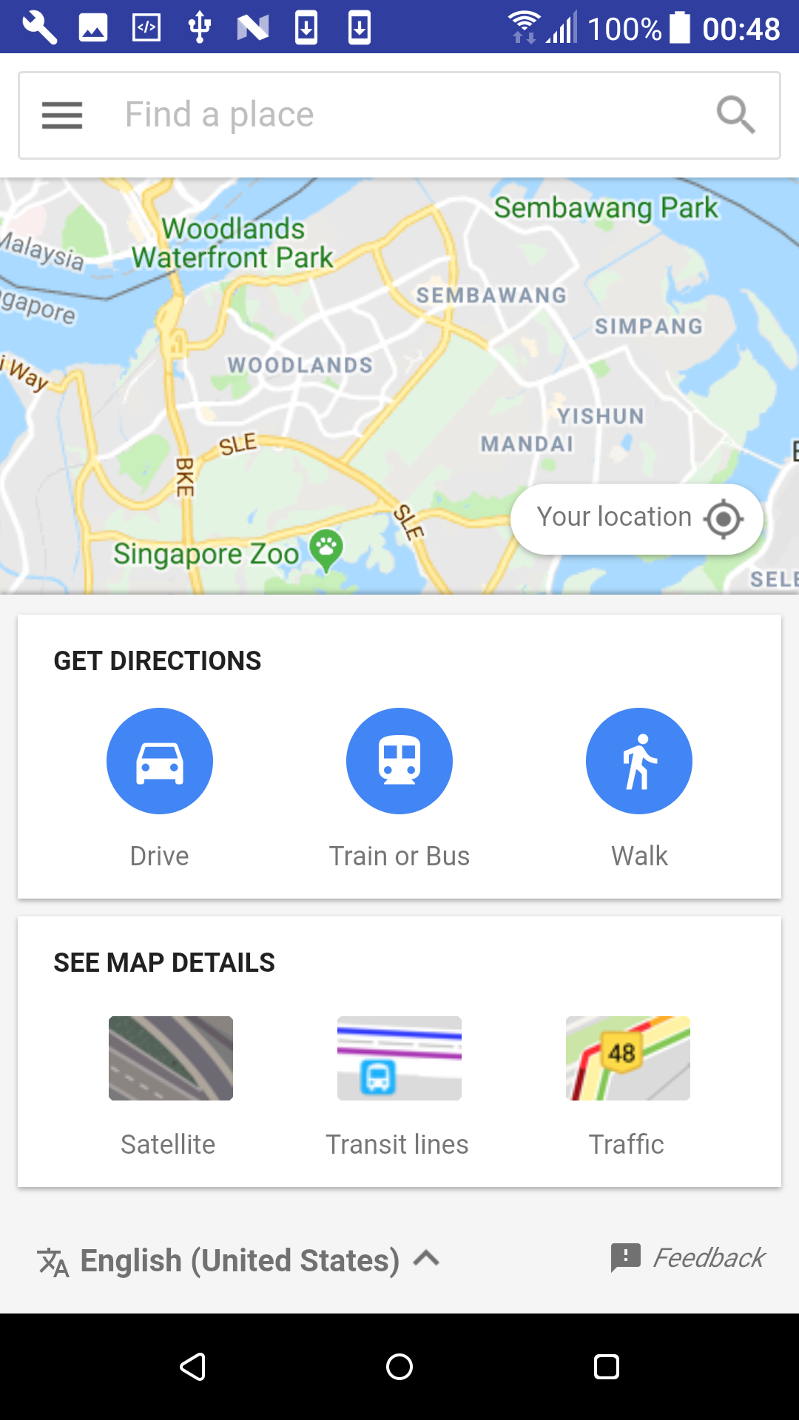

The user will be able to zoom in and scroll down on the map. Surrounding locations can be filtered based on user choices.

3.5.3 Audio recording of our meeting:

<https://drive.google.com/open?id=1InUwZg1L-LJrXp7TlaI4shqsU3xD37DH>

### 3.5.4 Burndown chart of Sprint 4

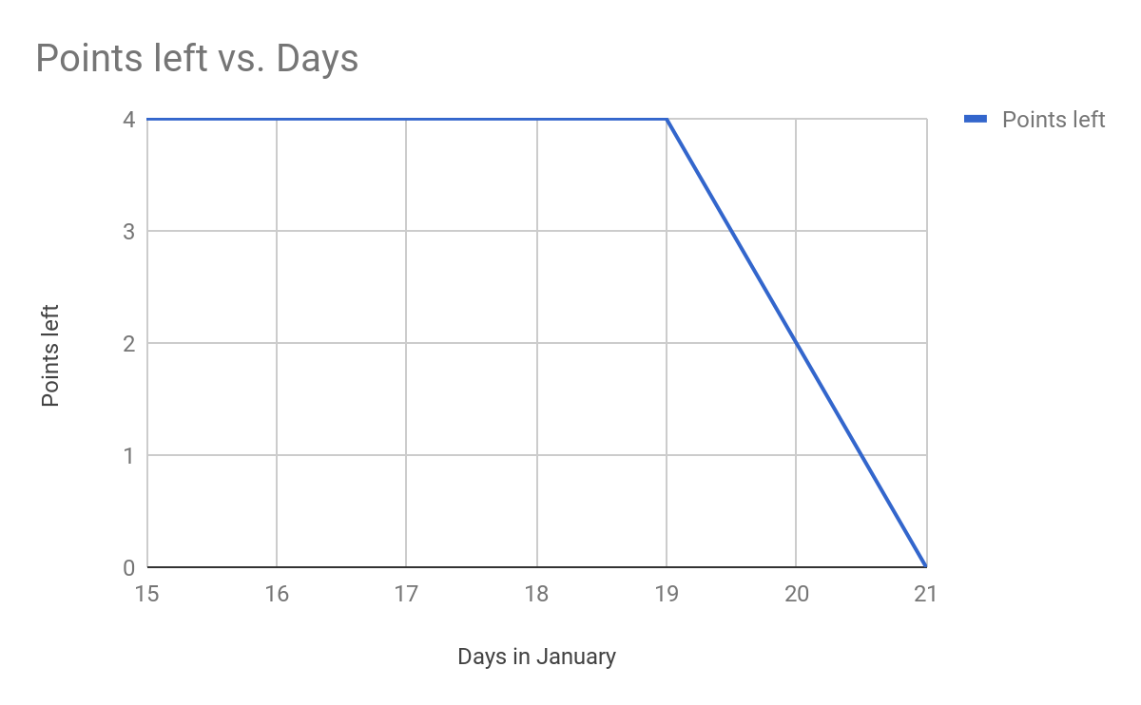

*Fig. 3.5d - Evidence 15, Burndown chart of Sprint 4*

### Burndown of Sprint 4

The last Sprint saw the last bit of functionality added. This is shown in the chart by illustrating the quick elminitation of points with a steep decline in evidence 15. The decline shows the functionality added and the parts completed aggressively before the deadline expires.

### 

## 3.6 Lecture 8

### 3.6.1 Mistakes made in the scrum rituals (Evidence 18)

**Sprint planning**

Initially we had set strict deadlines, and created an ambitious timeline to follow. However, once we started looking at the dates, we had to look at more realistic deadlines, as especially during the development phase we would run into problems that would take research to solve the issue when using Android Studio.

We had looked at doing 5 Sprints for the initial planning phase, however once we started with the first Sprint we realised that we would be able to complete our list of features given to us by the product owner in 4 Sprints, and time was a constricting factor that would ultimately allowed us not to do 5 Sprints in total.

**Daily Standup**

Our daily standups consisted of audio recordings done remotely as some members were not able to attend our physical meetups. We used software to conduct our meetings and to record our audio. There was also the issue of microphone quality that had to be sorted out, so that each member was able to be heard clearly, and be audible.

Another issue was that all members had to be present when these recordings were done, so to agree upon a time that would accommodate all members was a challenge as everyone had different schedules.

**Scrum Demo**

As it was difficult to always get the group together for consistent meetings we had done less Scrum demos than what we initially had planned to do.

**Scrum Retrospective:**

The Scrum retrospective gave the opportunity for the team inspect itself and create plan of improvements to be enacted in the next sprint. Initially, it was proposed to be a three hour meeting held by the scrum master with all the other team members present including the product owner and the developers. However, owing to the health reasons of a team member, the meetings for Sprint 2 and 3 lasted shorter than expected. Despite that the team was able to prepare and layout a plan for the next sprint. The project moved on to the next stage only after receiving the product owners approval on the implementation of the features.

After the Sprint 4, the team sat down together and discussed on the whole process of Scrum. We took inputs from each team member on the factors that worked/not worked well for them individually and as a team. We tried to look at things from a neutral perspective and discussed the measures that we employed in resolving these issues over the course of our journey.

This is summarised in the retrospective table below.

|  |  |
| --- | --- |
| **Factors that worked well** | **Factors that were problematic** |
| Every team member was able to identify with their individual roles | Communication between the team was affected because of the unavailability of the scrum master for a few days. This showed a considerable dip in our project work during Sprints 2 and 3 |
| Deadlines were met despite heavy workload | Some user stories were a big bigger than initially estimated. Specially in Sprint 2, where the registration functionality was implemented.We should have split them into smaller stories. |
| Functionalities achieved were in alignment with the user requirements | Estimation of the story points for Sprint 2 and 3 was not correct. We under performed in achieving our set goals during this phase. |
| Priority based feature development helped in meeting the deadlines during Sprint 2 and 3 | Scrum meetings were disorganised during Sprint 2 and 3 which affected our progress. |
| Vertically split small features improved estimation and planning in the final Sprint | It took some time to get used to the scrum rituals and methodologies. |

**What should be done in resolving the problem issues?**

* Make an accurate assessment of the potential of the development team in achieving their set goals. Over estimation can lead to decreased and inconsistent results
* Leave more space for sprint planning and future iterations in case of project delay or future project development.
* Make an appropriate estimation of the effort points needed to successfully implement the user stories into the application. Do not set unreachable goals that will unnecessarily increase the workload of the development team.
* If a team member is underperforming because of personal issues, the scrum master must make sure to communicate with him and resolve his concerns
* Daily scrum meetings should not postponed despite the unavailability of a few members. This will eventually slow down the project.
* Realistic goals must be set based on the potential of the current team and its state.

At the end of the Scrum retrospective meet, we were able to identify all the improvements that were made in our project and how we resolved the key issues in delivering the desired output.

## 

## 3.7 Lecture 9

### 3.7.1 Scrum values of the team (Evidence 19)

Appi-Gration Scrum Values

* Commitment
* Focus
* Openness
* Respect
* Courage

Withheld each of the scrum values

**Commitment:** It was decided early on that each team member will have their fair set amount of work to complete by certain deadlines. Majority of the time the team members adhered to this, and perfumed sometimes even more than what was expected of them.

**Focus:** The team showed a great deal of focus when it came to keeping the end goal in sight. All of our efforts were put into what the product owner requested, and what they required. Focus was also kept when work was assigned to each of the team members.

**Openness:** The team displayed a fair amount of openness especially when it came to an individual struggling with a certain topic or point. The team member would notify the rest, and seek help and suggestions. This was practiced multiple times when interacting with the scrum master and product owner. The product owner played a large role when it came to openness as this was all about transparency.

**Respect:** The team strictly adhered to that, in order for a Sprint to be successful we all showed mutual respect to one another and the product. Respect was displayed constantly in the group. Respect helped keep order and structure during challenging and time sensitive parts.

**Courage:** Sometimes team members would consider making suggestions, however, they worried that their input might not be well received nor make any contribution. The team took it upon themselves to promote feedback, and any comments, This displayed a boost in courage to each team member, and let them express themselves.

Violated each of the scrum values

**Commitment:** During some Sprint activities members would lose interest, and take some time to fully commit again to their specific parts, and stick to the deadlines given to them.

## 3.8 Final Lecture

### 3.8.1 Present the velocity chart of your team (Evidence 20)

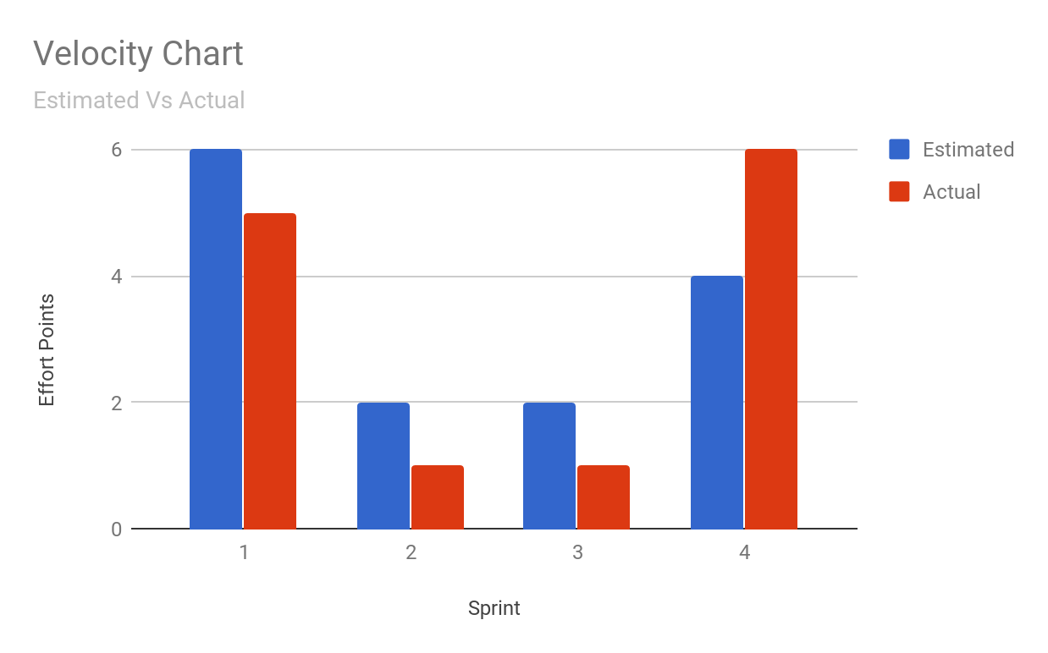

**Sprint 1**

This Sprint yielded a lower actual work against what we estimated we would be able to complete. The effort for Sprint 1 was significantly more than those of other Sprints due to the first workload being the most crucial. Although the effort put into the layout and UI there was still improvement to be done later on. This complements the histogram output in the sense of showing that the actual effort is less of than that of the estimated.

**Sprint 2**

In the introduction phase of Sprint 2 it was determined that one feature would be introduced by the product owner. The development team started working on the feature, the initial effort estimated to complete this activity was exaggerated. The actual effort needed was less than what was predicted. Sprint 2 focused on the development of the Registration function. Once the framework was built for this it could easily be incorporated into the following Sprint.

**Sprint 3**

The development team started working on the Login functionality for the application. The knowledge from the previous Sprint was used to minimise time taken to introduce this function. Once again a correlation was seen between the behaviour of effort from previous Sprints. This Sprint saw higher effort estimated and lower actual effort. This was due to the fact that previous understanding was incorporated into efficiently handling the function added into this Sprint.

**Sprint 4**

This Sprint was planned to be our last Sprint. We estimated the effort points, but once we started implementing the function for this Sprint we decided to do code cleanup and altered some of the UI elements as instructed to do by the product owner. This resulted in our velocity chart to show that there was more effort put into Sprint 4 than what we had initially estimated. The amount of value delivered in this Sprint is higher than the estimated value.

**Overall**

Comparing all of these Sprints, it is clear that there was a lack of effort in Sprint 2 & 3, however the effort points estimated always seemed to be more than what we actually accomplished in the sense of effort. Sprint 4 can be considered as the outlier, as here we tried to accomplish anything that was missing from our design brief. We squeezed in more features here, and overall accomplished more work during this Sprint, this is reflected on our velocity chart.